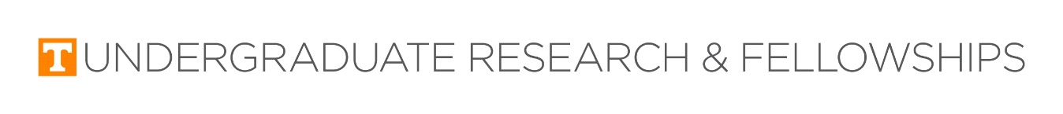

**Departmental Research Assistantship Program**

Student Application

Through this opportunity:

* Eligible undergraduates will work as employees on a faculty research project, earning ca. $1,500.00 over the course of the spring semester and gaining hands-on work experience in the research process
* Student employees will present some aspect of the research project at either the August 2022 Discovery Day poster event or the Spring 2023 EURēCA Poster Competition
* Student employees will have access to digital on-boarding materials in January to prepare for their spring research employment

*Students applying for this assistantship must meet all the following requirements. Please check all that apply:

__ Pell Grant eligible OR First Generation

__ Undergraduate Student

__ Have not previously received funding from the Office of Undergraduate Research and Fellowships

__ Not planning to graduate before December 2022

If you have checked all the boxes above, please continue the application.

*Student Information

1. First Name:
2. Last Name:
3. UTK Email:
4. Student NetID:
5. Major:
6. Expected Graduation Term & Year:
7. Are you currently employed or receiving funding from UT outside of the Federal Work Study program or Financial Aid? If so, please specify.

Research Project Information

1. Monday-Friday Availability:
2. Why are you interested in undergraduate research?
3. What skills do you have that will help inform your work as a researcher?
4. How will this assistantship support your future goals?
5. Please check which of the following projects interests you.

____Working on a project that studies the perceived authenticity and impact of virtual influencers in cause-related social media campaigns.

____Update and submit to a journal a previous conference paper (ICA) on the history of right to know.

and tying it to the current situations concerning fake news and lack of transparency to provide a

contemporary public relations fit for publication. Student Learning Outcomes: Undergraduate research assistant would benefit in several ways, including: (1) learning in detail how to write a publishable literature review, (2) gain a basic understanding and application of historiography, (3) learn to work with a senior faculty member on research, and (4) gain some insight into the academic publication process.